

The Lighthouse
Zion & Trinity Lutheran Churches
950 Huron
St. Ignace, MI 49781

Address Service Requested

Nonprofit Org.
U.S. Postage
PAID
St. Ignace, MI 49781
Permit No. 55
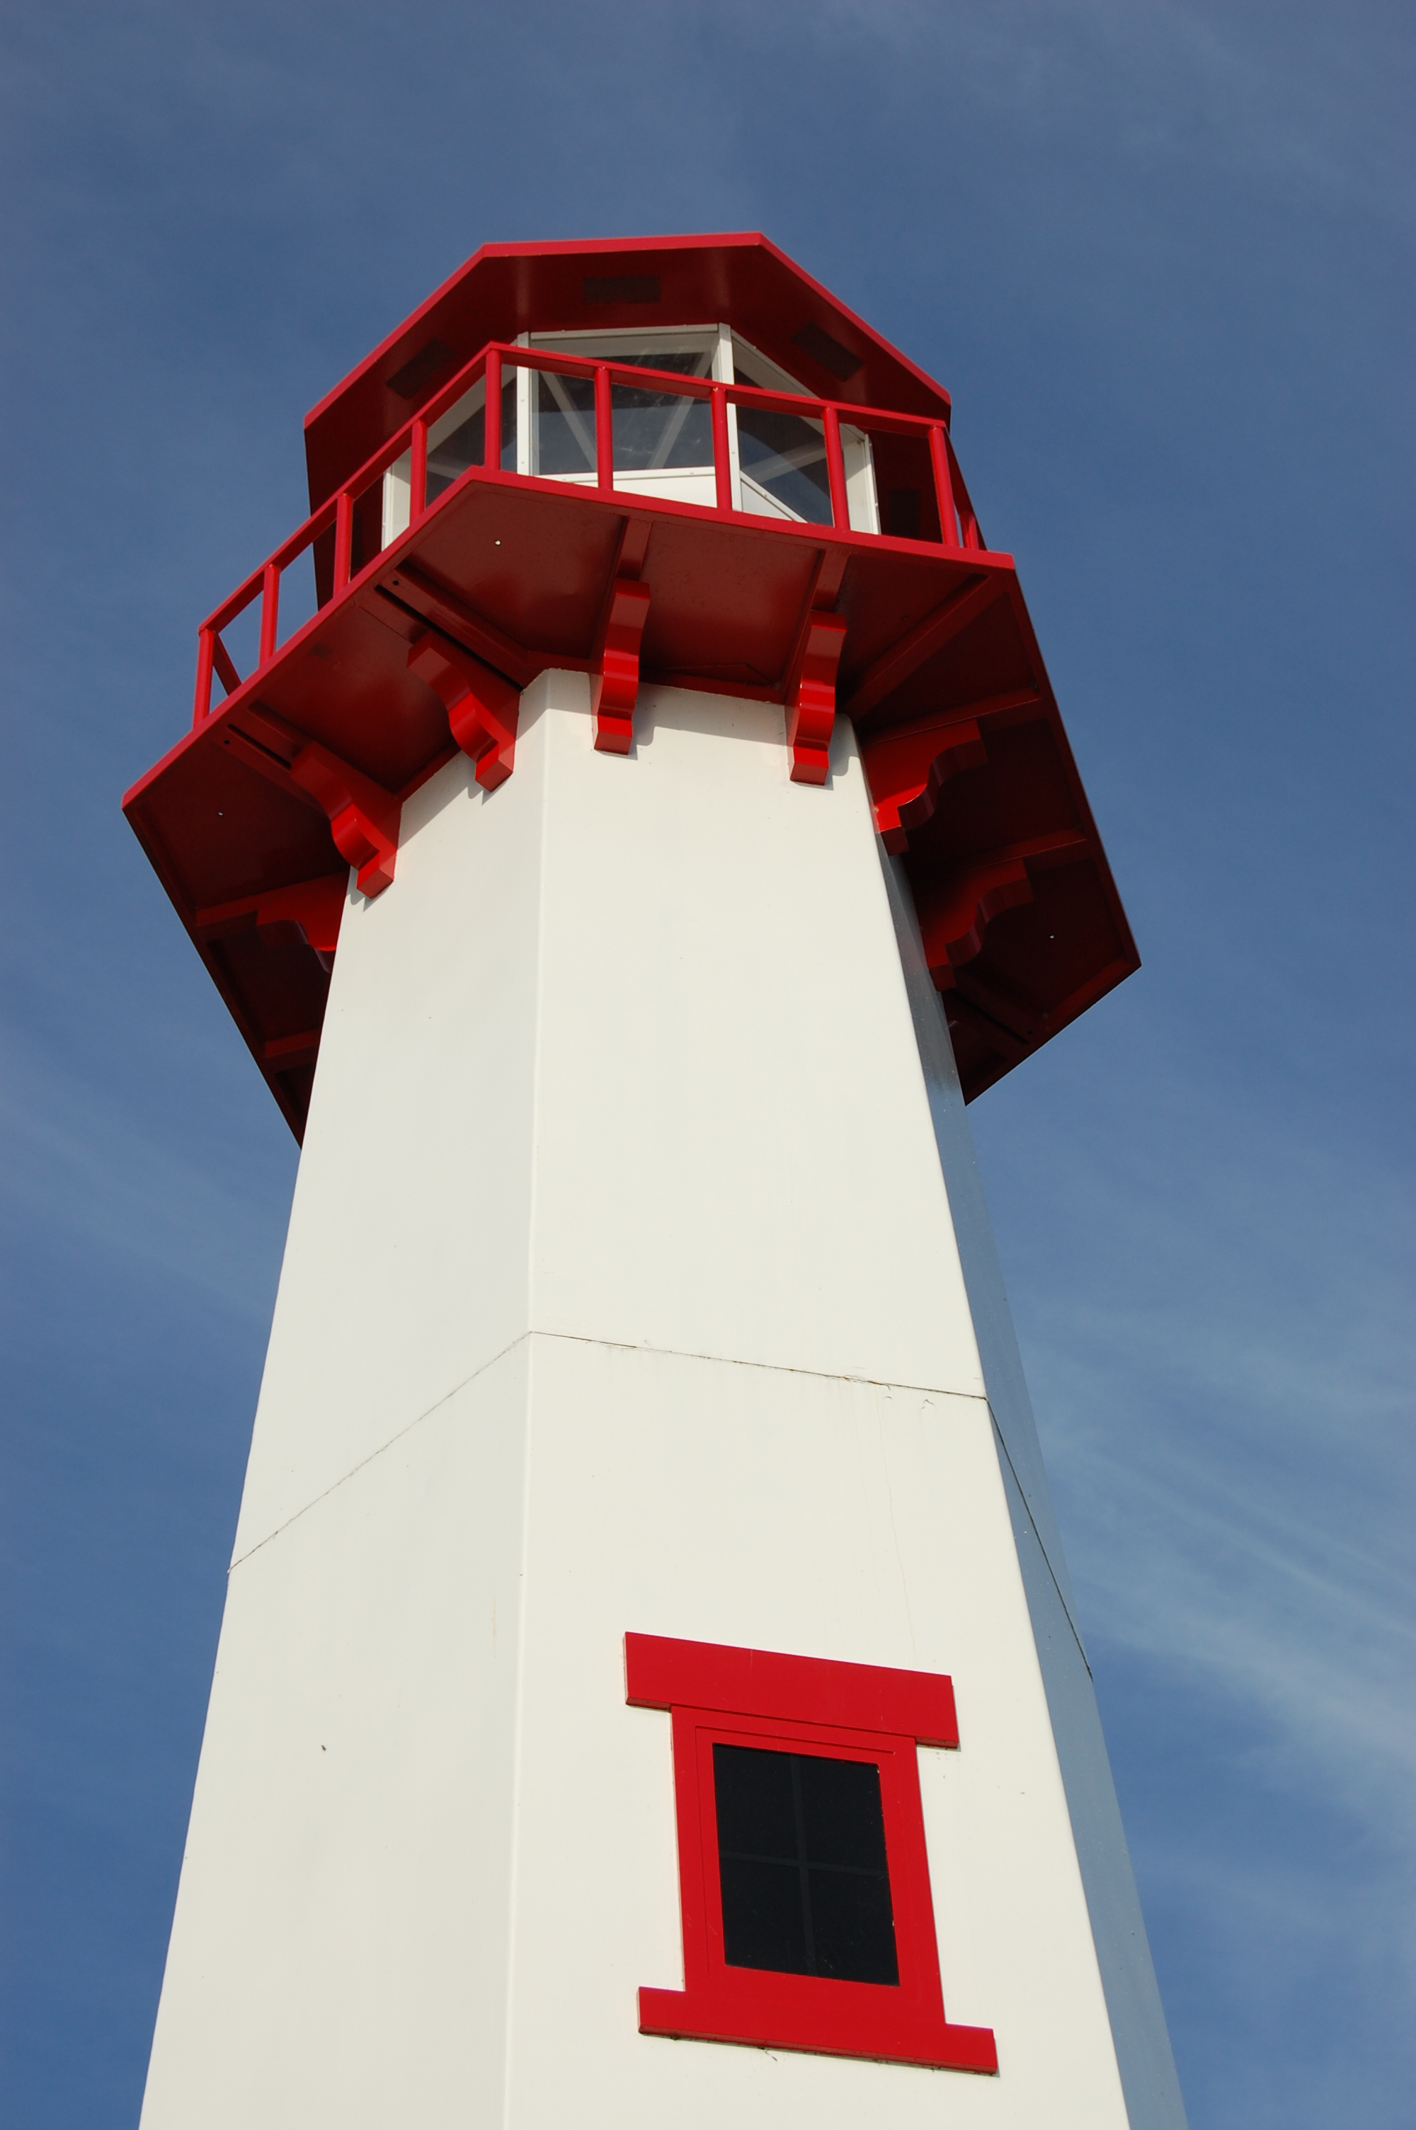
THE LIGHTHOUSE

Newsletter for August 2013

Who among you fears the LORD and obeys the word of his servant? Let him who walks in the dark, who has no light, trust in the name of the LORD and rely on his God. Isaiah 50:10

Message from Our Pastor

So apparently scientists have stumbled across something pretty amazing. They have now determined that dolphins have names. No, not Flipper, but actual dolphin names. Or at least the dolphin equivalent to names. After extensive tests they have discovered that individual dolphins will respond to its own “signature whistle”, which they had recorded and monitored ahead of time. They even would play other similar whistles but the dolphins would only respond when they heard their own whistle. Much in the same way we respond when hearing our own name called. Now I am telling you this not just because it is super awesome, but also because it shows just how truly amazing this creation God has made is.

I mean have you looked at the sky recently. I mean we all see the sky every day, but have you just sat and actually looked at it. Just watched the sky as the clouds rolled by. It is amazing and beautiful and truly is a wonder to behold. But of course so is so much of this world we live on. This world full of wonder and beauty. Beauty we know all about living on the Great Lakes. This world full of life, well beyond what we even know. This world where dolphins have names and a sunset can leave one breathless. This world, this creation, which has been given to us by God.
Given to us to enjoy and to use. Given to us to take care of. Which is a huge deal when you stop and think about it. We have been tasked with taking care of this creation and using it to continue to create and grow life. Which we are sometimes very good at. I grew up on a farm, I know very well how good we can be at growing life and using this creation. But we can also be very poor at it. Pollution, poaching, and reckless use of natural resources have been a part of our lives for far too long now. Which is why it is so important for us, who recognize creation for the gift from God that it is, to be out there in the world taking care of this gift. Doing what we can to preserve it and save it for future generations. Ensuring that years from now this same beauty and wonder will be there for others to see and know their creator as we have. It is too important a gift not to.

Newsletter

The August Newsletter was not adopted. ☹

Trinity & Zion Bible Study

Bible Study on 2 Samuel will continue at Trinity on Fridays at 1 pm. Bible Study on 1 Samuel will continue at Zion on Thursdays at 7 pm.

Noisy Offering

The noisy offering for August 4th will go for
Project Backpack.

Vacation Bible School

August 5-9 we will be having Vacation Bible School at Zion. We will need lots of help to have a successful program at lots of different capacities. So, if you are interested please talk with Pastor Jeremy as soon as possible.

Steak Dinner

We will be having our 3rd Annual Steak Dinner on August 17th, from 5 p.m. to 7 p.m. You will receive steak, salad, potato, drink & dessert for a suggested donation of $10.00. Come enjoy the meal and the company!

Trinity-Zion Joint Church Picnic

We will be having a “Joint Picnic” with Trinity and Zion Churches at 1:00 pm on August 18th. It will be a pot luck held at the Dock #3, Coast Guard Park.

Zion’s Service Sunday for August

On Service Sundays, we go out into the community together to help others and do God’s work. On August 25, I invite everyone to stick around after church when we will join together for a meal and then fill backpacks for “Project Backpack”.

If you have suggestions for future projects that will help the community, please contact a council member or the Pastor.

Zion Funeral Committee April - July

Team Leader: Linda Wilkins (643-7710)
Co-leader: Marialana Nygard (231) 436-7235

Servants for Zion

Ushers & Greeters
Aug 4 Judy Ryerse & Marialana Nygard
Aug 11 Stevan & Mary Christiansen
Aug 18 Feleppa Family
Aug 25 Mike Lehto & Bob Marshall

Lectors
Aug 4 Betsy Turf
Aug 11 Dawn Akers
Aug 18 Linda Wilkins
Aug 25 Sandy Feleppa

Communion Assistants
Aug 4 Faith Gaubault
Aug 11 Paul Shepard
Aug 18 Tim Idalski

Altar: Lorraine Graham
Money Counters: Lorraine Graham & Lana Lennington

Trinity Worship Families

Aug 4 The Movalson Family
Aug 11 The Baron Family
Aug 18 The Lamoreaux Family
Aug 25 The Chalmers Family
Council Meetings

Trinity Council Meeting – 6 pm, August 19
Zion Council Meeting – 6:30 pm, August 20

Zion’s Council Members

Treasurer: Dawn Akers 643-7552
Jerry Fenlon 643-8730
Susan Fenlon 643-8730
Faith Gaubault 298-1800
Paul Shepard 984-2069
Tim Idalski 643-6574
Fred Feleppa 643-6793
Lorraine Graham 643-8419

Trinity’s Council Members

President: Jerri Rose 292-5570
Vice-President Tracy Movalson 292-5581
Secretary: Sharon Chalmers 292-5440
Treasurer: Pega Kennedy 292-5633
Co-Treasurer: Jim Rose 292-5570
Financial Secretary: Joe Chalmers 292-5433
WELCA: Pega Kennedy 292-5633
John Kennedy 292-5633
Jim Dyer 292-5433
Lois Movalson 292-5581

Treasurer's Report for Zion
January 1, 2013 through July 13, 2013
Income:
 | Building | $3,445.00
 | Church Use Income | $0.00
 | General | $38,665.07
 | Thrivent Financial | $435.00
 | Trinity Share | $7,385.00
 | TOTAL |  | $49,930.07
Expenses:
 | Administration | $3,244.13
 | Benevolence | $3,875.00
 | Church Maintenance | $8,702.22
 | Education | $268.27
 | Parsonage Maintenance | $1,318.17
 | Pastoral | $26,040.19
 | Worship | $2,215.89
 | --To Building Fund | $3,466.51
 |  |  | $49,130.38
Balance: |  |  | $ 799.69
***********************************************************
7/13/2013
General fund owes Building fund: |  |  | $ 8,196.00
General fund owes Mission Endowment fund: |  |  | $ 9,995.00
General Fund balance: |  |  | $ 1,048.07
Building Fund balance: |  |  | $ 13,746.37
Thrivent Investment Management Fund: |  |  | $ 299.87
WELCA Kitchen Fund: |  |  | $ 9,763.54
2011 -2013 Capital Campaign Donations |  |  | $ 19,189.00

Trinity Lutheran Church Council Meeting
July 15, 2013
The meeting began at 6:40 p.m. following a potluck supper and prayer. Those present were Tom and Joyce Gustafson, Jim and Jeri Rose, Joe and Sharon Chalmers, Norm Dyer, Lois Movalson, and Pastor Jeremy.
Pastor's Report: Pastor proposed a joint church picnic for August 11th. Zion will choose the location. Pastor performed his first wedding at Trinity.
Secretary's Report: Read and Approved
Treasurer's Report: Read and Approved
Financial Secretary's Report: Read and Approved
OLD BUSINESS
1. Missionaries: the council voted to support the missionaries, Krystle Moraska-Madrussan and Ignacio Madrussan in Argentina.
2. Endowment Interest: We discussed spending accumulated interest earned on new tables, table cloths, new paraments, fixing stained glass, and carpeting for the basement.
NEW BUSINESS
1. We will get a fan in front of the organ.
2. The elevator certificate arrived in the mail and is posted.
3. We agreed to fill two backpacks. Pega will do the shopping.
The meeting was adjourned with the Lord's Prayer at 7:10 p.m.
Respectfully Submitted,
Sharon Chalmers

Zion Lutheran Council Meeting
July 16, 2013

Present: Pastor Jeremy, Fred Feleppa, Jerry Fenlon, Susan Fenlon, Faith Gaubault, Tim Idalski, Paul Shepard and Dawn Akers

Zion’s Counsel met Tuesday July 16, 2013. Called to order at 6:40. Opened with devotion.

Secretary’s Report: June minutes approved, motion Jerry, support Fred. Passed.

Treasurer’s Report: June Financial statements and quarterly budget estimates reviewed and discussed. Motion Fred, support Tim. Passed.

Pastor’s Report:

- Only 3 youth to attend Fortune Lake this year.

- VBS scheduled for August 5-9. New Methodist pastor has been invited to participate. Using same curricula as after-school program so some costs savings.

- Steak Supper set for 8/17. Might try pre-selling tickets.

- 8/18 for joint picnic with Trinity. At Dock 3 / Coast Guard Park.

- Pastor on vacation 9/1.
- 9/8/13 is 25th year Anniversary for establishment of ELCA, which will be commemorated with world-wide service Sunday. Working on coordinating with that. No service project in August.

- July service project is Long-Term Care.

- Discussed how to change Pastor’s compensation with him going on Liz’s health insurance and to share those savings with him and prevent budget problems if we need to provide insurance in the future. Will have details on ELCA sponsored health-IRA options in August.

- New stoves are in the Kitchen. Old stoves will be announced for give-away to congregation. If nobody claims, will donate to HOPE.

- A memorial was received, and discussed setting aside for anticipated copier replacement.

- Discussed displaying some historic photos / memorabilia.

- Decided to purchase two new chairs / stools for kitchen.

Adjourned at 8:35 with the Lord’s Prayer.

Respectfully submitted,
Fred Feleppa

Birthdays in August

Aug 2 Amber Anderson
Aug 2 Molly Dandona
Aug 5 Cierra Barker
Aug 6 Joe Chalmers
Aug 6 Bailey Ryerse
Aug 7 Sandy Feleppa
Aug 8 Ethan Shepard
Aug 8 Craig Therrian
Aug 11 Adrian Coleman
Aug 11 Chelsey Coleman
Aug 11 Madison Coleman
Aug 13 Tyler Chambers
Aug 14 James Campbell
Aug 14 Stephanie Jenkins
Aug 14 Lana Lennington
Aug 14 Dottie Glashaw
Aug 16 Cole Garen
Aug 17 Shari Baron
Aug 19 Haley Dodds
Aug 21 Matthew Rogers
Aug 22 Donovan Insley
Aug 23 Lisa Rogers
Aug 24 Nicole Garen
Aug 25 Kristine Vallier
Aug 26 Gary Sorenson
Aug 27 Les Therrian
Aug 28 Duane Gamble
Aug 29 Gunnar Olsen
Aug 30 Michael Gaubault
Aug 30 Jim Ryerse
Aug 31 Savannah Barker

Baptismal Anniversaries

August 1 Linda Wilkins

August 1 Dianne Nelson
August 10 Aubree Vallier
August 12 Debbie Therrian
August 18 Bob Brandstrom
August 18 Wendy McCluskey
August 20 Abby LaLonde
August 28 Nevaeh Wells
Anniversaries in August

August 6 Mark & Carol Elmblad
August 6 Michael & Faith Gaubault
August 10 Ernie & Stephanie Vallier
August 17 Bob & Debbie Brandstrom
August 17 Jon & Connie Olsen
August 23 Durance & Becky Paul
August 28 Charlie & Audrey Stenson
August 28 Les & Debbie Therrian

Prayer List

Bonnie Bergeron, Ann Dyer, Jim Dyer, Carl Belonga, Mary Belonga, Ruth Cope, Dan Pope, LaTaunya Paquin, Christine Movalson Shaw, Silas Robert, Phil Richel, Paul Grondin, Regina Turner, Nadine Dandona, Jackie Kallstrom, Ronald Lennington, Pat Bell, Mary Streeter, Amy Kinjorski, Janice Werkheiser, Joy Olsen Marolf, Ken Smith, Larry Leveille, Karen Schlehuber, Chris Barker, Pam Kaminsky, Karen O’Keefe, Brenda St. Onge and Kristine McDonald.

Contact Information

Pastor Jeremy Winter may be reached at 906-643-0391 or at jwinter001@gmail.com or in case of emergencies,
Pastor’s cell phone number is 712-389-2747

Church telephone: 906-643-7870 - Answering machine
The secretary is in the office on Tuesdays & Thursdays.

The email address for the church is: ziontrinity950@yahoo.com
The website is at www.lutheransonline.com

